ENG G130 • Fall 2019 • Writing Project 3 • Launch Article 1

Face Tattoos Go Mainstream. For some people, face tattoos are no longer taboo.
Adapted from Steven Kurutz (2018) from The New York Times

At the Chicago Tattooing & Piercing Company, a store where a customer can get a tattoo, the employees have a name for tattoos on the hands, neck, and face. Joel Jose Molina, a tattoo artist (= an employee who draws tattoos on customers) at the store, remarks that such tattoos are called ‘job stoppers’ because they decrease a person’s chances of getting a job. Molina asserts that people who have tattoos on their face are unlikely to find conventional employment such as in an office, grocery store, or restaurant.
For decades, tattoos in highly visible areas, especially the face, were considered taboo. Many people regarded them as examples of extreme body art, at least in Western culture. It wasn’t only conservative people who felt this way about face ink. Even among tattoo aficionados (= people who really like tattoos), the face was sacrosanct, a canvas of last resort when the rest of the body was already covered with tattoos. To illustrate, Molina reports that he has done only three face tattoos over his 12-year career at the Chicago Tattooing & Piercing Company. Two of them were on other tattoo artists, while the third one was on a gangster from Florida who sold illegal drugs and wanted his eyelid tattooed. JonBoy, a New York-based tattoo artist who has tattooed many celebrities, joked that he used to walk to the other side of the street, if he saw someone with a face tattoo. Indeed, people used to think that someone with a face tattoo might be a member of the racist Aryan Brotherhood or a gang member or a sideshow performer in a circus. Famous face tattoo wearers of the recent past, like the boxer Mike Tyson, the murderer Charles Manson, and the drug-addled skateboarder Jay Adams, conformed to the stereotype of the rough character.

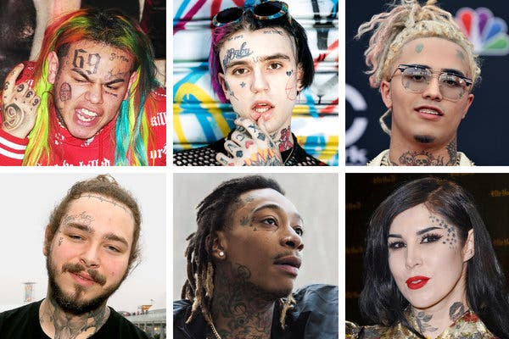
Clockwise from top left, Tekashi 6ix9ine, Lil Peep, Lil Pump, Kat Von D, Wiz Khalifa and Post Malone.

Social attitudes towards tattoos began to change over the years. Anna Felicity Friedman, a scholar who runs the website Tattoo Historian, maintains that it became more commonplace to see athletes and celebrities with body tattoos beginning in the 1990s. Soon, magazines and reality TV shows (with titles like “Best Ink” and “Tattoo Nightmares”) began covering tattoo culture, and Americans embraced body art like never before. Tattoos started losing their renegade status. As a result, they began to creep upward, past the neckline.
Musicians and other celebrities were among the first people to get tattoos on their faces. Post Malone has “Stay Away” in curly script on his forehead and the words “Always” and “Tired” below each eye, while Justin Bieber has a tiny, under-eye cross. Other artists with inked faces include 21 Savage (a knife on his forehead), Lil Xan (the words “xanarchy” and “candy,” the number “1996”), and Tekashi 6ix9ine (the number “69,” a red flower, the face of Jigsaw from the “Saw” movies). Kat Von D, a tattoo artist and model, has a wash of blue stars trailing down her forehead and cheek. Friedman argues that rappers use face tattoos to create a transgressive character. They believe that face ink gives them a rebel or criminal allure that might be good for music sales. Other celebrities feel that face tattoos are a reference to their free spirit or artistic talent. Post Malone has offered a simpler explanation for his face tattoos to reporters. He got them to upset his mom.
With the notable exception of Lil Wayne and Wiz Khalifa, two heavily inked established artists, many of the hip-hop stars with face tattoos are so-called SoundCloud rappers, that is, young, unknown artists who post their music on SoundCloud for free. These unknown artists use face tattoos to attract attention. Travis Hardy, a creative director in Los Angeles who works with musicians, explains that many younger rappers are getting face ink to make themselves bigger on social media. For example, Kerwin Frost, a member of the Spaghetti Boys creative collective, has a tattoo of a realistic pencil that runs the entire length of his right cheek. Frost notes that people have diverse reactions to his face tattoo. Some people love it; others become angry and scream at him when they see it. Frost argues that he can have the tattoo removed with laser technology in the future, if he decides that it is no longer working for him professionally.
Although more and more rappers and celebrities are getting face tattoos, many people believe that they will not become commonplace among the general public anytime soon. Molina, the Chicago tattoo artist, explains that most people who are getting face tattoos in his store are young and work in untraditional jobs. He states that he would never get a face tattoo himself because he believes that the teachers in his children’s school would judge him negatively. Echoing the feeling of many people in the tattoo community, Molina also maintains that a face tattoo should never be someone’s first time getting inked. When an 18-year-old woman recently asked him for a tattoo on her ear, he saw that she had no other visible tattoos and convinced her not to get the ear tattoo. Molina believes that getting a face tattoo is a rite of passage that must be earned.

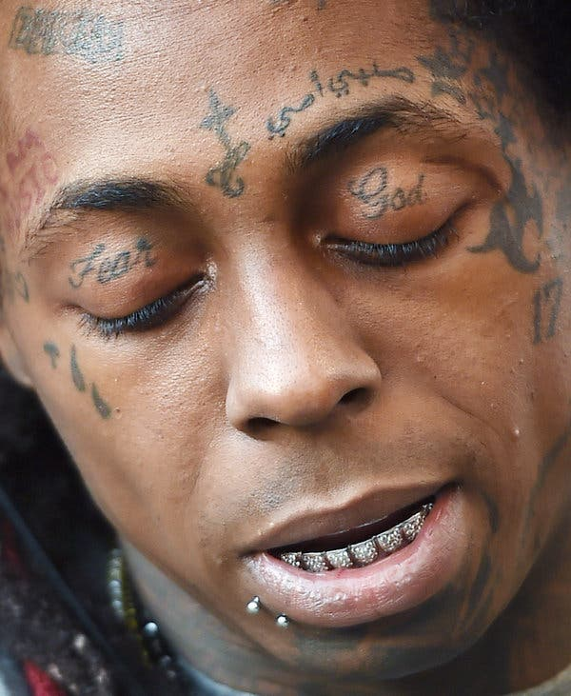
Lil Wayne, a rapper who embraces face tattoos.

